**HUMAN BIOLOGY UNIT 2**

**GENETICS EXTENDED RESPONSE VALIDATION**

**WEIGHTING 4%**

**NAME: _________________________ DATE: ___________ Total Marks ____/ 29**

1. The pedigree below shows the inheritance, within a family, of a very rare disorder called Gingus Rangus Monobrowii where the affected individual has red hair and only one eyebrow.

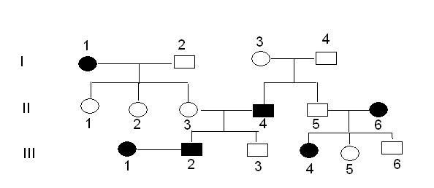

1. Is the disorder inherited as a dominant or recessive trait? (1 mark)

1. Explain how you arrived at your answer in (a) (1 mark)

____________

1. Is the trait autosomal or X-linked? (1 mark)

1. Explain how you arrived at your answer in (c). (1 mark)

1. Using R and r what are the genotypes of the following individuals (3 marks)
   * 1. I.2
     2. I.3
     3. 1.4
     4. II.3
     5. II.5
     6. III.3
2. Draw a correct pedigree from the following information, using the initial letters of the names of the people involved (eg 'N' for Norman). A freehand drawing is acceptable. **(5 marks)**

Alan is married to Beatrice. They have five children born in the following order, Cheryl, Douglas, Edward, Frederick and George. Sadly, Frederick died as a baby. Cheryl is married to Henry and George is married to Isabelle. Cheryl and Henry have two daughters, Julie (eldest) and Kate. Leonard and Martin are brothers. Their mother is Isabelle. The second sons and first daughters all have a recessive genetic condition.

1. Explain the difference between a single gene disorder and a chromosomal disorder. Give an example of each. (6 marks)

______

1. The pedigree shown below represents the inheritance of a genetic condition that affects normal vision. A student examined this pedigree and concluded that the condition is a sex-linked recessive disorder. On the basis of this information, answer the questions below. In your analysis, use the letters N or n

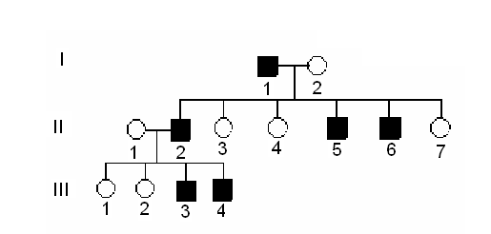

1. What is the probability that individual II-4 is a carrier? Show your working. (3 marks)
2. What is the genotype of all the affected males? (1 mark)
3. If individual III-2 married and had children with an infected person, what is the chance that their child will have the condition? Show your working (3 marks)
4. The ABO blood grouping system displays two phenomena in genetics. Explain the following terms and give an example using the ABO system.
5. Multiple Alleles (2 marks)

1. Co-dominance (2 marks)

**END OF VALIDATION TEST**